

SNM / CNF Project Report

Documentation of the Practical Project Conducted as Part of the CNSM Course

Submitted by

Gabriel Crisan | Tudor Cinteza
gabriel.crisan1601@stud.acs.upb.ro | tudor.cinteza@stud.acs.upb.ro
UNSTPB, Faculty of Automatic Control and Computer Science | UNSTPB, Faculty of Automatic Control and Computer Science
65 | 48
Intrarea Mandolinei 9, Sector 1, Bucharest, Romania | Street Moinesti No. 16, Bloc 206, Sc. A, Ap. 38, Bucharest, Romania

Submitted to

Examiner: | Prof. Dr. Alexandru Soceanu
Advisor: | Maximilian Schmitz
Submission Date: | 18.01.2026

Statutory declaration
I hereby declare that I have composed this project report independently and without using any sources or aids other than those explicitly cited. Sentences or parts of sentences quoted verbatim are marked as such, and all other references to statements and their scope are provided with full details of the respective publications. This report has not been submitted in the same or similar form to any examination body and has not been published. It has not been used, in whole or in part, in any other examination or as coursework.


Additionally, I declare that any use of Artificial Intelligence (AI) in the preparation of this report has been explicitly noted. If AI-based tools or technologies were employed, their use is clearly indicated to avoid any potential issues with plagiarism or AI detection checks.

Bucharest, Romania 18.01.2026
Place, Date Signature


Bucharest, Romania 18.01.2026
Place, Date Signature

List of abbreviations
(Should be listed in ascending order in respect to their lexicographical order)
#: | Abbreviation: | Description:
1 | ARP | Address Resolution Protocol
2 | BGP | Border Gateway Protocol
3 | CLI | Command Line Interface
4 | DMZ | Demilitarized Zone
5 | DNS | Domain Name Server
6 | DoS | Denial of Service
7 | GPL | General Public License
8 | GUI | Graphical User Interface
9 | HTTP | Hypertext Transfer Protocol
10 | HTTPS | Hypertext Transfer Protocol Secure
11 | ICMP | Internet Control Message Protocol
12 | IDS | Intrusion Detection System
13 | IP | Internet Protocol
14 | IPS | Intrusion Prevention System
15 | LAB | Laboratory Network Zone
16 | LAN | Local Area Network
17 | MAC | Media Access Control
18 | NAT | Network Address Translation
19 | OSPF | Open Shortest Path First
20 | RIP | Routing Information Protocol
21 | SIEM | Security Information and Event Management
22 | SNM | Secure Network Management
23 | SPL | Splunk Processing Language
24 | SSH | Secure Shell
25 | TCP | Transmission Control Protocol
26 | UDP | User Datagram Protocol
27 | VLAN | Virtual Local Area Network
28 | VPN | Virtual Private Network
29 | WAN | Wide Area Network
Table 1 List of abbreviations

Abstract/Summary
The final project of the Secure Network Management course consists of designing and simulating a secure virtual infrastructure, where we will conduct a set of controlled cyber-attacks in order to observe and analyse the real-time traffic between components, resulting in valuable information which helps us reinforce protection rules and mitigate potential threats.
To ensure the successful implementation and testing of our network, the following objectives and phases were established:
- Topology sketch and design – defining the network architecture, placement of the pfSense firewall, hosts and other components

- Attacks planning – brainstorming the flow of each attack and how it should be performed within our topology

- Component configuration – from connectivity testing to firewall rules, we checked and configured each section of our virtual network

- Attacks implementation – creating custom Python scripts for each attack

- Putting everything together – assembling the whole environment and making sure that Snort and Wireshark are able to capture traffic between components

- Testing and results – launching each attack and monitoring the outcomes to see if they all are as expected
Regarding the project’s constraints and technical boundaries, we had to work within the 192.168.40.0 – 255 pool range, which we subnetted to organize our virtual environment. The central point of the project is the pfSense firewall (DMZ1) that runs Snort as an IDS/IPS, forwarding all logs to a Splunk SIEM in order to have an organised monitoring. The attacks our team simulated are 2 Reconnaissance Attacks, 2 Denial of Service Attacks and 1 extra RIP Attack.
The main expectation of the project was to prove that our firewall and Snort rules could successfully detect the Scapy attacks. We used Splunk and Wireshark captures to visualise the real-time impact of the attacks on our environment, which ultimately helped us validate that our configuration does indeed mitigate the effects of these threats.
Table of Contents
1. Introduction 7
1. Objective 9
2. Analysis/Result Section 19
A. Introduction 19
3. Conclusion and Recommendations 26
4. Bibliography 27
A. Appendix A 28
A.1. Phase 1 – Endpoint configuration 28
A.2. Phase 1 – VyOS Routers 29
A.3. Phase 2 – Enable RIP 30
A.4. Python Code Fragments 30
A.5. Wireshark Excerpts 32
List of figures 34

Introduction
- Topology overview
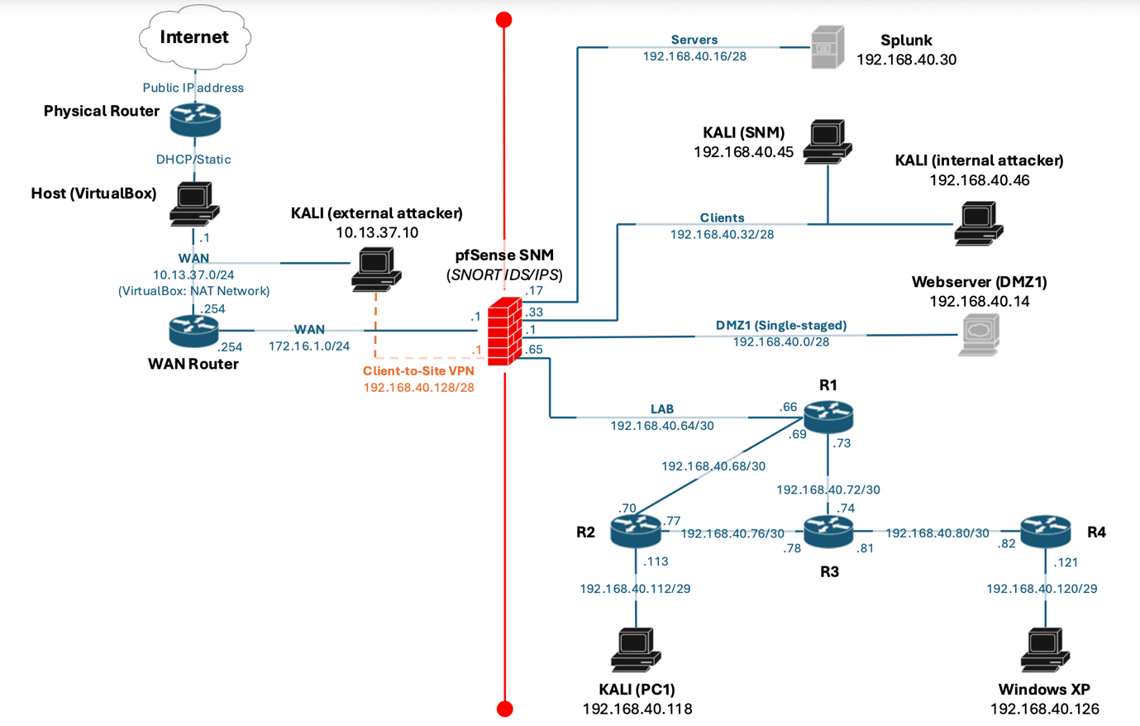

The network is segmented into multiple security zones:
- DMZ (single–stagged) – Webserver
- Servers – SIEM from Splunk
- Clients – Kali (SNM) & Kali (Internal Attacker)
- LAB (routing domain) – R1-R4 & Kali (PC1) & Windows XP

pfSensese acts as the central firewall and routing boundary. The lab zone contains 4 VyOS routers (R1 – R4) interconnected using RIPv2. All internal networks are allocated within the pool range 192.168.40.0 – 255.

- Addressing plan

- Endpoint addressing table

Endpoint name | Role | Interface | IP address | Subnet | Gateway
pfSense | Firewall / Router | DMZ | 192.168.40.1 | 192.168.40.0/28 | -
pfSense | Firewall / Router | Servers | 192.168.40.17 | 192.168.40.0/28 | -
pfSense | Firewall / Router | Clients | 192.168.40.33 | 192.168.40.32/28 | -
pfSense | Firewall / Router | LAB | 192.168.40.65 | 192.168.40.64/30 | -
Webserver | DMZ | Eth0.10  (VLAN 10) | 192.168.40.14 | 192.168.40.0/28 | 192.168.40.1
Splunk | SIEM Server | Eth0 | 192.168.40.30 | 192.168.40.16/28 | 192.168.40.17
Kali SNM | Management / Admin | Eth0 | 192.168.40.45 | 192.168.40.32/28 | 192.168.40.33
Kali Internal Attacker |  | Eth0 | 192.168.40.46 | 192.168.40.32/28 | 192.168.40.33
Kali PC1 | LAB Host | Eth0 | 192.168.40.118 | 192.168.40.112/29 | 192.168.40.113
Windows XP | LAB Host (Victim) | Eth0 | 192.168.40.126 | 192.168.40.120/29 | 192.168.40.121
Table 2: Endpoint addressing table

Note: Due to the limitation of available physical network adapters on the pfSense machine, VLAN tagging is used to multiplex multiple zones over a single physical interface.

- LAB subnet & Router Link table

Subnet | Mask | Link Description | Device A | Device B
192.168.40.64 | /30 | pfSense ↔ R1  (VLAN 20) | 192.168.40.c5  (em3.20) | 1S2.1c8.40.cc  (eth0.20)
192.168.40.68 | /30 | R1 ↔ R2 | 192.168.40.cS | 1S2.1c8.40.70
192.168.40.72 | /30 | R1 ↔ R3 | 192.168.40.73 | 1S2.1c8.40.74
192.168.40.76 | /30 | R2 ↔ R3 | 192.168.40.77 | 1S2.1c8.40.78
192.168.40.80 | /30 | R3 ↔ R4 | 192.168.40.81 | 1S2.1c8.40.82
192.168.40.112 | /29 | R2 ↔ Kali PC1 | 192.168.40.113 | 1S2.1c8.40.118
192.168.40.120 | /29 | R4 ↔ Windows XP | 192.168.40.121 | 1S2.1c8.40.12c
Table 3: LAB subnet & Router Link table

- External network & VPN Allocation

Component | Network | IP (Range) | Note
VirtualBox NAT (WAN) | 10.13.37.0/24 | 10.13.37.1 | Used to simulate Internet
WAN Router | 172.16.1.0/24 | 172.16.1.254 | Upstream gateway for pfSense
pfSense WAN | 172.16.1.0/24 | 172.16.1.1 | Internet-facing interface
Client-to-Site VPN | 192.168.40.128/28 | 192.168.40.129-142 | Pool of IP addresses to assign  to VPN clients
Kali (External Attacker) | 10.13.37.0/24 | 10.13.37.10 | Becomes internal attacker
Table 4: External network & VPN Allocation

- Phase 1 – Base addressing & basic connectivity

Objective

The objective of Phase 1 is to configure static IP addressing on all devices and verify basic, local connectivity.

At the end of Phase 1:
- all interfaces have correct IP addresses;
- hosts can reach their default gateway only;
- no dynamic routing is enabled;
- LAB routers do not exchange routes.

- pfSense configuration

Interface and VLAN Setup

Because pfSense has a limited number of physical adapters, we are using VLANs.
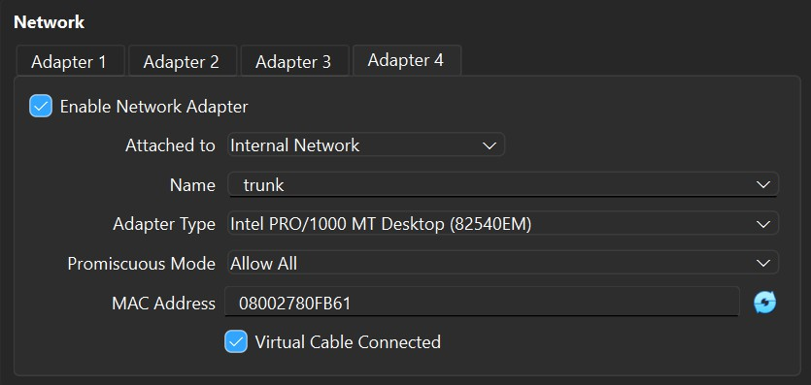

VLAN ID | Zone | pfSense interface
10 | DMZ | Em3.10
20 | LAB | Em3.20
Table 5: VLAN Setup

The physical interface em3 acts as an 802.1Ǫ trunk (Promiscuous mode: Allow All; name : trunk).

Interface IP Configuration

To configure interfaces directly using GUI, inside Kali SNM, the pfSense Clients interface, acting as gateway for endpoints inside the Clients subnet, must be configured using pfSense CLI. After being able to successfully ping 192.168.40.33 from Kali SNM, pfSense can be accessed using its GUI. Remaining interfaces can be configured from Interfaces → [Interface Name].
Because of the limited number of adapters, VLANs must be created from Interfaces → Assignments → VLANs → Add. These VLANs interfaces must be assigned to DMZ (em3.10) and LAB (em3.20).

Temporary Firewall Rules

These rules are temporary and are used only to simplify connectivity testing. They will be replaced in later phases.
On each interface (DMZ, Servers, Clients, LAB):
- Action: PASS
- Protocol: IPv4 Any
- Source: Interface net
- Destination: Any

- Endpoint configuration

View Appendix A.1. Phase 1 – Endpoint configuration

- VyOS Routers (no RIP)

View Appendix A.2. Phase 1 – VyOS Routers

- Expected results
By the end of the first configuration phase, this is the expected behaviour of the topology:
• hosts can ping their gateway
• hosts can reach other subnets (Clients cannot reach LAB)
• LAB hosts cannot reach Clients

- Phase 2 – Dynamic routing with RIP

- Objective

Phase 2 introduces RIP v2 inside the LAB routing domain and ensures bidirectional connectivity between firewall-managed networks and LAB hosts.

- Enable RIP

View Appendix A.3. Phase 2 – Enable RIP
- Static route injection
pfSense does not run RIP, so R1 must inject firewall-side networks. Configurations that will be shown in this section are specifically for R1, which means that the remanining routers will maintain current configuration and no other commands will be added.

Static Route on R1:

set protocols static route 192.168.40.32/28 next-hop 192.168.40.65

Redistribute Static Routes into RIP:

set protocols rip redistribute static

- pfSense: Static route addition

Create gateway

System → Routing → Gateways → Add

- Interface: LAB
- Gateway IP: 192.168.40.66
- Name: GW_LAB_R1
- disable monitoring (Important!)

Add static route

System → Routing → Static Routes → Add

- Destination: 192.168.40.0/24
- Gateway: GW_LAB_R1

- Expected Results

By the end of the second configuration phase, this is the expected behavior of the topology:

- Fully routed (RIP Routes should appear marked with R; static route with S)
- Intentionally insecure (all communication between subnets is allowed)
- Reproducible

- Phase 3 – Firewall rules & Snort configuration

- pfSense: Alias definitions

Objective: In this step, we created aliases to group network addresses and port numbers in order to make the firewall configuration clearer and easier to manage. By using these aliases, the rules become more readable and better organized, which helped us with understanding their purpose.

IP Address & Network Aliases were created for the main segments of the topology and specific hosts:
CLIENTS_Network
- Type: Network
- Value: 192.168.40.32/28
- Description: Represents the client zone (users + internal attacker)
DMZ_Network
- Type: Network
- Value: 192.168.40.0/28
- Description: DMZ zone, containing the Webserver
SERVERS_Network
- Type: Network
- Value: 192.168.40.16/28
- Description: Internal servers zone, containing the Splunk SIEM
LAB_HOSTS_Networks
- Type: Networks
- Values: 192.168.40.112/29 & 192.168.40.120/29
- Description: LAB networks for hosts, containing the Kali (PC1) and Windows XP end devices
Individual Host Aliases:
- HOST_KALI_SNM: 192.168.40.45 (Management workstation in the clients subnet)
- HOST_Splunk: 192.168.40.30 (Splunk SIEM Server for log collection)
- HOST_WEBSERVER_DMZ: 192.168.40.14 (The target web server in DMZ1)
Port Aliases:
- PORT_HTTP_HTTPS: 80, 443 (http/https web services)
- PORT_SPLUNK_INGEST: 9997 (TCP port used by Splunk to send logs)
- PORT_SPLUNK_WEB: 8000 (Port for Splunk Web UI)
- PORT_SSH: 22 (Secure Shell management)
- pfSense: Firewall rules configuration
We implemented the following firewall rules to limit network access to only what is necessary for the system to function correctly. The rules are organized based on interface zones to make the configuration easier to understand and to clearly define what type of traffic is permitted in each zone:

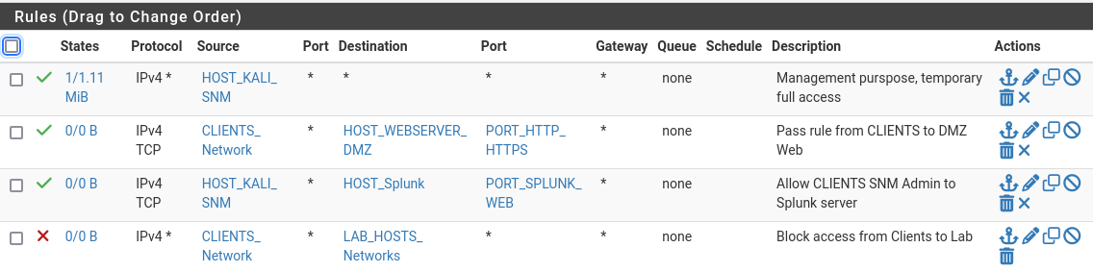
Figure 1: Clients zone firewall rules

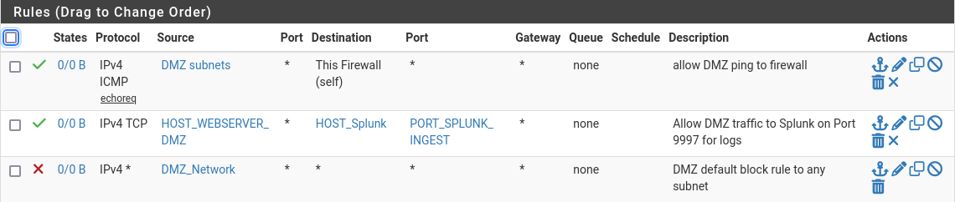
Figure 2: DMZ zone firewall rules

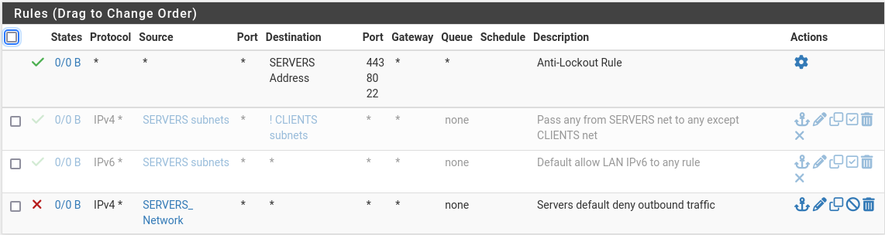

Figure 3: Servers zone firewall rules
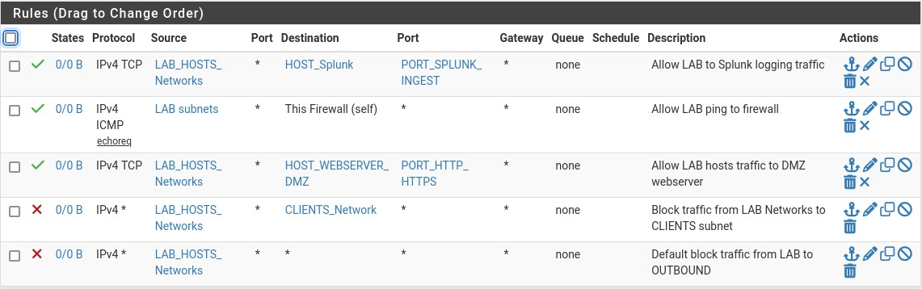
Figure 4: LAB zone firewall rules

- Snort IDS/IPS configuration
While our firewall rules check traffic using IP addresses and ports, we also used Snort to spot malicious activity or scanning attempts that the firewall by itself might miss.
- Rule sets & Interface assignment
To establish a layer of security we downloaded and enabled the GPLv2 Community Rules package. We also configured Snort interfaces to monitor critical network segments:
- WAN (em0): Configured to detect external attacks targeting the infrastructure
- CLIENTS (em2): Configured to detect internal threats or compromised hosts
- Custom rules definitions
We also configured specific custom rules to monitor unusual traffic behaviors such as RIP routing updates, DMZ access and specific scan types:
Rule 1: ICMP Reconnaissance detection
- Purpose: It detects ping sweeps and checks to see which devices on the internal network can be reached
- Syntax: alert icmp any any -> $HOME_NET any (msg:"ICMP Recon Detected"; sid:1000001; rev:1;)
Rule 2: TCP SYN Scan detection
- Purpose: Identifies port scanning attempts used to discover open ports
- Syntax: alert tcp any any -> $HOME_NET any (flags:S; msg:"TCP SYN Scan Detected"; sid:1000002; rev:1;)

Rule 3: Webserver monitoring
- Purpose: Logs specific HTTP traffic directed towards the DMZ Webserver (192.168.40.14) to monitor how frequent it is accessed
- Syntax: alert tcp any any -> 192.168.40.14 80 (msg:"HTTP Access to DMZ Webserver"; sid:1000003; rev:1;)
Rule 4: RIP Protocol monitoring
- Purpose: Detects RIPv2 routing updates
- Syntax: alert udp any any -> any 520 (msg:"RIP Routing Update Detected"; sid:1000004; rev:1;)
Rule 5: DoS protection (SYN Flood)
- Purpose: Detects potential Denial of Service attacks by tracking the rate of SYN packets. It triggers if a source sends more than 20 SYN packets in 10 seconds.
- Syntax: alert tcp any any -> $HOME_NET any (flags:S; threshold:type both, track by_src, count 20, seconds 10; msg:"Potential SYN Flood"; sid:1000005; rev:1;)

- Splunk configuration
- pfSense: Log forwarding setup
We configured pfSense to act as a syslog client, forwarding system and security events to the internal Splunk server.
Configuration Steps:
- Navigate to: Status → System Logs → Settings → Remote Logging Options
- Remote Log Servers: 192.168.40.30:5140 (Splunk Server IP and listening port)
- Remote Syslog Contents:
  - System Events: Enabled (for general system health)
  - Firewall Events: Enabled (to capture Snort alerts and filter logs)

- Splunk: Alert & Query configuration
For every custom Snort rule defined in Phase 3, we created a corresponding alert in Splunk. These are the SPL queries we implemented to trigger alerts and visualize threats:
- HTTP access to DMZ – Monitors traffic matching the Snort SID regarding web server access, formatting the output into a readable table
Query:

index=main sourcetype=syslog "HTTP Access to DMZ Webserver"
| rex field=_raw "}\s(?<src_ip>\d+\.\d+\.\d+\.\d+)(?::\d+)?\s->\s(?<dest_ip>\d+\.\d+\.\d+\.\d+)"
| table _time, src_ip, dest_ip

- RIP Routing Update Detection – Detects unexpected routing updates and renames the source IP to "Potential Attacker"
Query:
index=main sourcetype=syslog "RIP Routing Update Detected"
| rex field=_raw "}\s(?<src_ip>\d+\.\d+\.\d+\.\d+)"
| stats count by _time, src_ip
| rename src_ip AS "Potential Attacker"
- SYN Flood Detection – Checks for sources sending too many SYN packets
Query:
index=main sourcetype=syslog "Potential SYN Flood"
| rex field=_raw "}\s(?<src_ip>\d+\.\d+\.\d+\.\d+)(?::\d+)?\s->\s(?<dest_ip>\d+\.\d+\.\d+\.\d+)"
| stats count by src_ip, dest_ip
| where count > 20
| sort – count

- ICMP Reconnaissance Detection – Spots possible ping sweeps by counting ICMP messages between sources and targets

Query:

index=main sourcetype=syslog "ICMP Recon Detected"
| rex field=_raw "}\s(?<src_ip>\d+\.\d+\.\d+\.\d+)\s->\s(?<dest_ip>\d+\.\d+\.\d+\.\d+)"
| stats count by src_ip, dest_ip
| where count > 10

- TCP SYN Scan Detection – Observes port scanning attempts by extracting and counting unique source-destination pairs from the logs.
Query:
index=main sourcetype=syslog "TCP SYN Scan Detected"
| rex field=_raw "(?<src_ip>\d{1,3}\.\d{1,3}\.\d{1,3}\.\d{1,3})"
| rex field=_raw "->\s(?<dest_ip>\d{1,3}\.\d{1,3}\.\d{1,3}\.\d{1,3})"
| stats count by src_ip, dest_ip

Analysis/Result Section

Introduction

This part of the project focuses on validating the security aspect of our infrastructure through traceable attack simulations. The goal is to demonstrate that the defensive mechanisms configured in previous phases (Firewall Rules, Snort IDS, Splunk SIEM) function correctly by detecting and logging potential threats.
All attacks were executed in our virtual environment using the following attackers and targets:
Attackers:
- Kali Internal (.46): Simulates a compromised host inside the LAN
- Kali External (.10): Simulates an external threat machine
- Kali SNM (.45): Used as an attacker because of its privilages (management workstation)
Targets:
- pfSense Firewall: The primary enforcement point
- DMZ Webserver: Target for application attacks
- LAB Environment: Routing infrastructure (RIP) and legacy hosts (Windows XP)
- Attack #1: Reconnaissance – ARP Sweep
The attacker, located in the Clients network (192.168.40.46), attempts to find all live hosts within the local subnet (192.168.40.32/28) to identify potential targets and the gateway, by sending ARP requests.

Python Script – View Appendix A.4. Python Code Fragments (Script 1)

Validation & Traffic analysis

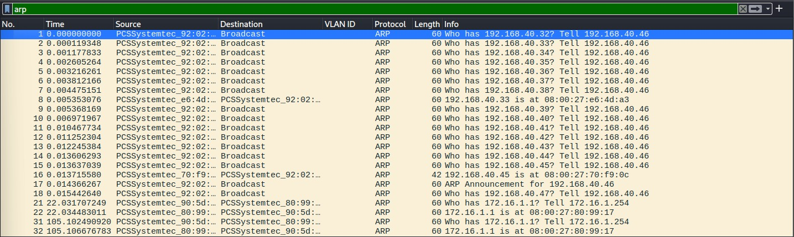
Wireshark capture 1: Attack #1 – ARP Sweep

The attack was successfully captured using Wireshark, the capture file demonstrating the nature of this scan:
- Packets 1- 7: At first, we can observe a burst of ARP Broadcasts. The source 192.168.40.46 sequentially queries for 192.168.40.32, .33, .34, .35, etc. This sequential behavior is a clear indicator of an automated scan rather than normal traffic
- Packet 8: The host at 192.168.40.33 (the pfSense gateway) responds with its MAC address (08:00:27:e6:4d:a3), confirming its presence to the attacker
- Packet 16: Other hosts in the network (e.g. .45) are also identified, which allows the attacker to build a map of the network segment

- Attack #2: Reconnaissance – TCP SYN Scan
In this scenario, an external attacker (10.13.37.10) scans the firewall through port forwarding to identify open ports on the web server. TCP SYN packets are sent to ports 1–1024 and when a port responds, a RST packet is sent to close the connection.
Python Script – View Appendix A.4. Python Code Fragments (Script 2)

Validation & Traffic analysis
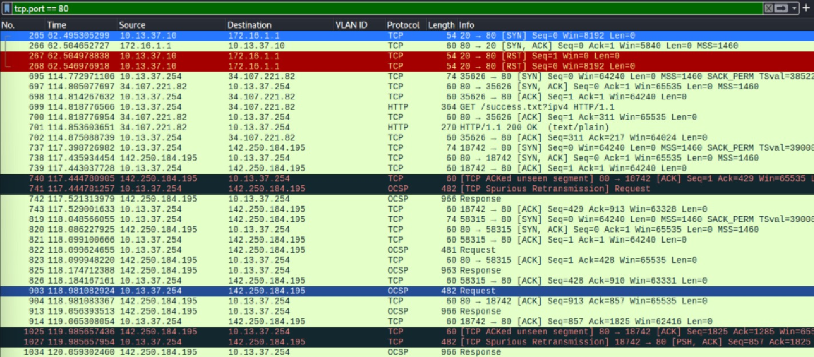
Wireshark capture 2: Attack #2 – TCP SYN Scan

- Packet 265: We can see that the attacker (10.13.37.10) sends the initial [SYN] packet to the target (172.16.1.1) on port 80
- Packet 266: Then, the target replies with [SYN, ACK]. This is the indicator that Port 80 is indeed OPEN and forwarding traffic to the DMZ
- Packet 267: Instead of sending an ACK to finish the handshake (which would be normal traffic), the attacker sends a [RST]. This closes the connection to avoid creating a fully established session on the web server
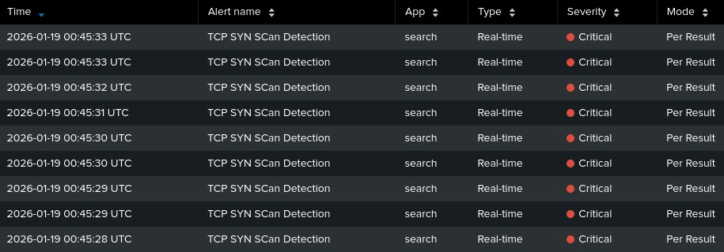
Splunk capture 1: Attack #2 – TCP SYN Scan
- We observe that the dashboard is populated with multiple "TCP SYN Scan Detection" alerts marked as Critical
- The timestamps also show that multiple ports were hit within seconds, confirming the unusual traffic

- Attack #3: Denial of Service – TCP SYN Flood
The internal attacker (192.168.40.46) launches a resource exhaustion attack against the DMZ web server (192.168.40.14). The attack floods port 80 with many spoofed TCP SYN packets, filling the firewall’s state table and creating half-open connections, which makes the web service hard to reach or even unavailable.
Python Script – View Appendix A.4. Python Code Fragments (Script 3)

Validation & Traffic analysis

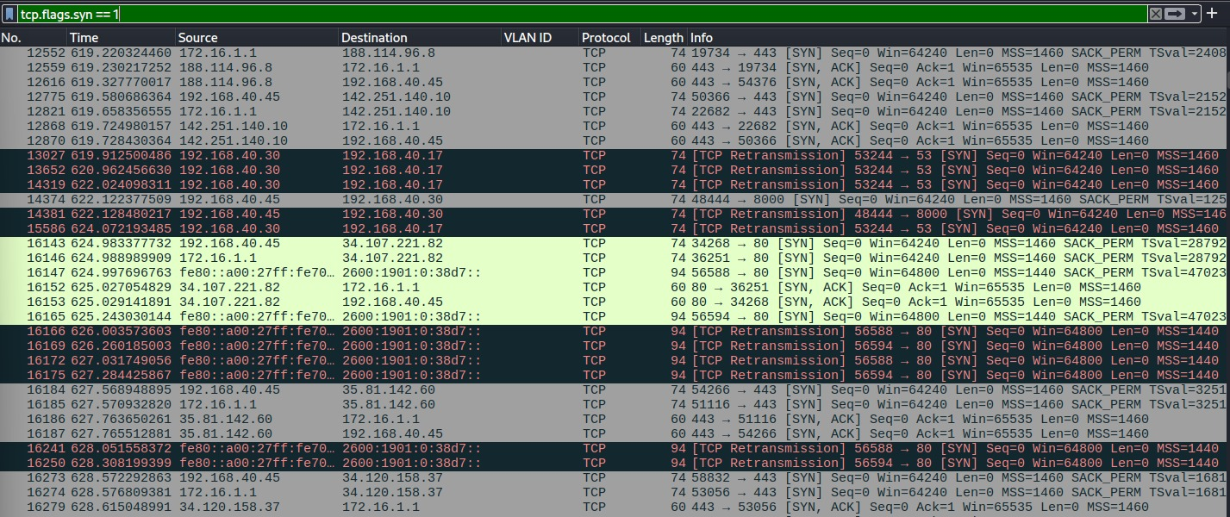
Wireshark capture 3: Attack #3 – TCP SYN Flood

- The capture highlights the presence of TCP SYN packets attempting to initiate connections. We can observe a high volume of these packets without corresponding ACK or FIN flags, indicating that connections are being initiated but not closed
- The packets marked in black and red represent TCP Retransmissions. This signifies that the attacker is not receiving any response (SYN-ACK) from the Webserver, confirming that the target system is overloaded and unable to process new connection requests

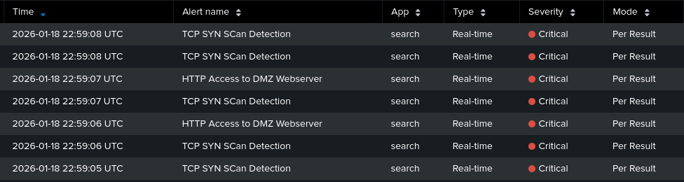
Splunk capture 2: Attack #3 – TCP SYN Flood

- We can observe that the Splunk dashboard displays multiple events marked with Critical severity.
- Also, there are alerts (visible at 22:59:05 through 22:59:08) that appear in rapid succession, confirming the aggressive nature of the attack

- Attack #4: Denial of Service – ICMP Flood
For this attack, we used the Kali SNM management station (192.168.40.45) because it has permission to send traffic into the restricted LAB network. The target is a Windows XP machine (192.168.40.126), which is flooded with ICMP Echo Request packets. This high amount of traffic overloads the system, causing very high CPU usage and making the machine unresponsive.
Python Script – View Appendix A.4. Python Code Fragments (Script 4)

Validation & Traffic analysis

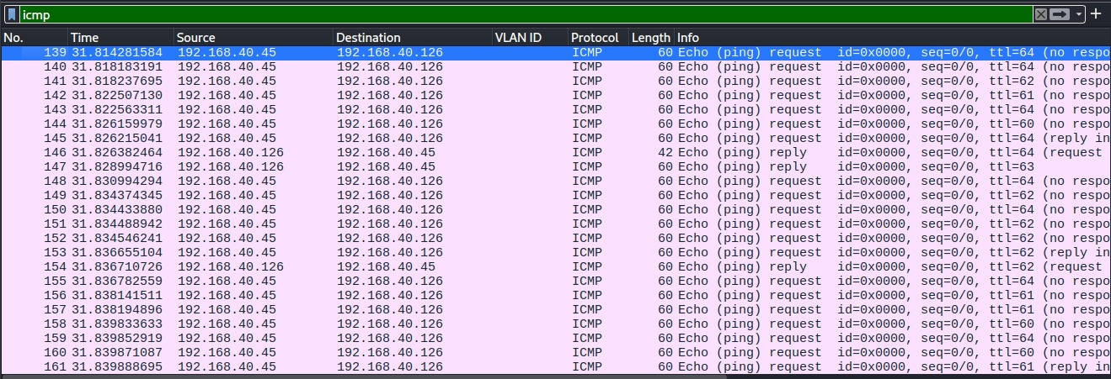
Wireshark capture 4: Attack #4 – ICMP Flood

- Packets 139-145: We observe a rapid burst of "Echo (ping) request" packets originating from 192.168.40.45 towards 192.168.40.126
- More than this, Wireshark tags several requests with "(no response found!)", indicating that the requests are arriving faster than the victim or the analyzer can match them with a reply
- We can conclude that the DoS attack is affecting the target

- Attack #5: RIP Attack
In our Extra-Attack, the internal attacker (192.168.40.46) exploits the lack of authentication in RIPv2 to send a fake routing update. The script advertises a better route to the victim (192.168.40.126) through Kali (PC1) (192.168.40.118), causing routers to redirect traffic away from the real target.

Python Script – View Appendix A.4. Python Code Fragments (Script 5)

Validation & Traffic analysis

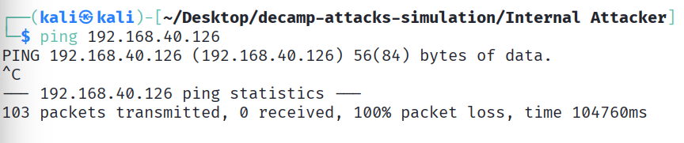
Terminal 1: Attacker’s terminal

- As we can see in the attacker's terminal a standard ping to the target 192.168.40.126 results in 100% packet loss
- This result confirms us that the valid route to the victim has been corrupted, cutting the victim off from the network

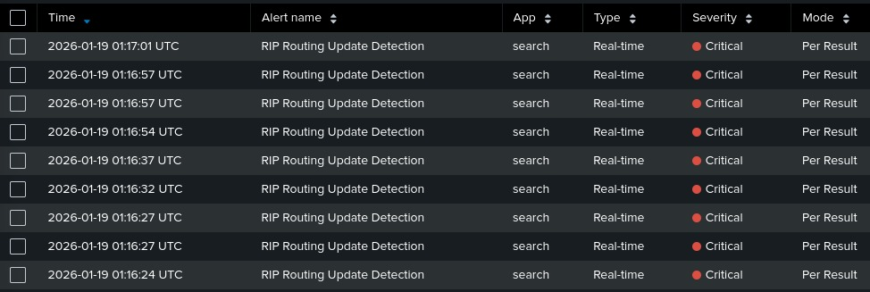
Splunk capture 3: Attack #5 – RIP Attack

- The Splunk dashboard shows us a series of "RIP Routing Update Detection" alerts marked as Critical
- The system flagged these events because routing updates on UDP port 520 were sent from a client IP (192.168.40.46) that is not allowed to take part in routing

Conclusion and Recommendations
The implementation of the virtual network and the attacks conducted as a part of this project showed us that using only perimeter firewalls is not enough to secure a modern network. Even though pfSense rules successfully divided the network into zones like DMZ, Clients and LAB, the attack scenarios proved that internal attacks or exploits can still happen.
From our traffic analysis, we can conclude that combining Snort with Splunk SIEM greatly improves network security. The firewall controls who can communicate, but Snort and Splunk help identify what type of traffic is passing through, such as detecting scans, floods or fake routing updates.

Our conclusions for improving security:
- Every outdated protocol should be replaced. The routing attack demonstrated us that RIPv2 is insecure because it has no authentication, therefore in real networks it should be replaced with more secure protocols like OSPF or BGP

- The success of ARP sweep attacks inside the LAN shows the need for better protections and a more advanced Layer 2 security.

- Legacy systems should be isolated or upgraded. The Windows XP machine proved to be very vulnerable, so if such systems cannot be upgraded, they should be placed in a separate VLAN with no internet access and monitored closely to prevent them from being exploited.

Bibliography

[1] Prof. Dr. Alexandru Soceanu, "Project report guideline,” [Online].
Available: https://moodle.hm.edu. [Accessed 10 08 2024].

[2] Prof. Dr. Alexandru Soceanu, "Topics 1 - 7", Assignments "1 - 11", [Online].
Available: https://moodle.hm.edu. [Accessed January 2026].

[3] Google. (2026). Gemini 1.5 Pro [Large language model].
Available: https://gemini.google.com/

[4] OpenAI. (2026). ChatGPT Plus (GPT-5.2) [Large language model].
Available: https://chat.openai.com/

Appendix A

Phase 1 – Endpoint configuration

WEBSERVER (DMZ)
sudo nano /etc/network/interfaces

Edit network configuration:
auto lo
iface lo inet loopback
netmask 255.255.255.240
gateway 192.168.40.1
dns-nameservers 8.8.8.8

Apply:
sudo reboot

Verification:
ping 192.168.40.1

Note: The Webserver adapter must be named exactly as pfSense last adapter was
named (trunk) and Promiscuous mode must be set to Allow all.

SPLUNK SERVER

sudo nano /etc/netplan/00-netcfg.yaml

Edit network configuration:
network:
version: 2
ethernets:
eth0:
addresses:
- 192.168.40.30/28
gateway4: 192.168.40.17
nameservers:
addresses:
- 8.8.8.8

Apply:
sudo netplan apply

Verification:
ping 192.168.40.17
KALI (SNM)

sudo nano /etc/network/interfaces

Edit network configuration:
auto lo
iface lo inet loopback
auto eth0
iface eth0 inet static
address 192.168.40.45
netmask 255.255.255.240
gateway 192.168.40.33
dns-nameservers 8.8.8.8

Apply:
sudo systemctl restart networking

Note: Similar configurations will be assigned to Kali (Internal Attacker), Kali (PC1), Windows XP (modify the ID properly, gateway as well, netmask might change between configurations).

End hosts must not have VLAN subinterfaces!

Phase 1 – VyOS Routers
R1
configure
set interfaces ethernet eth0 vif 20 address 192.168.40.66/30
set interfaces ethernet eth1 address 192.168.40.69/30
set interfaces ethernet eth2 address 192.168.40.73/30
delete interfaces ethernet eth0 address
commit
save
exit

Note: Similar configurations will be assigned to R2, R3, R4. (we need to make sure that every router has as many adapters as interfaces). The only distinction is that R1 must have the adapter responsible for eth0 (Adapter 1) named exactly as pfSense adapter was named (trunk) and Promiscuous mode must be set to Allow all.

Phase 2 – Enable RIP
R1

configure
set protocols rip interface eth0
set protocols rip interface eth1
set protocols rip interface eth2
set protocols rip network 192.168.40.0/24
commit
save
exit

Note: Similar configurations will be assigned to R2, R3, R4.

Python Code Fragments

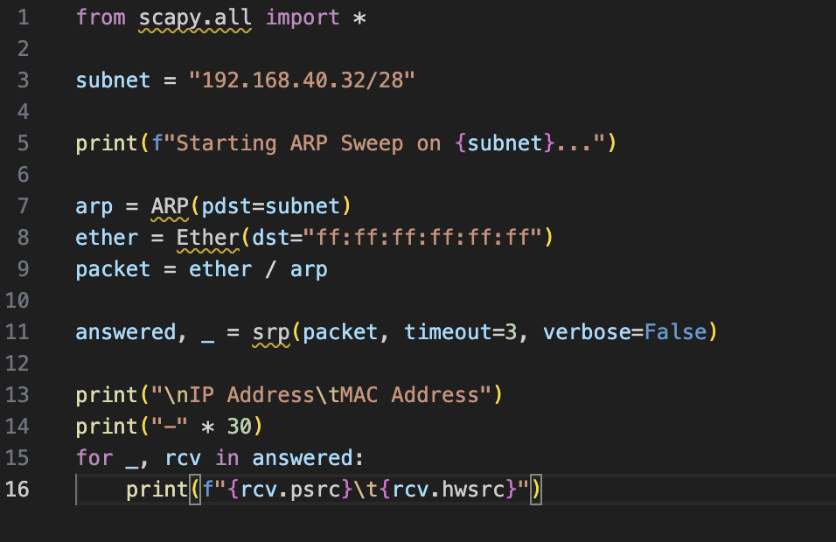
Script 1: Attack #1 – ARP Sweep

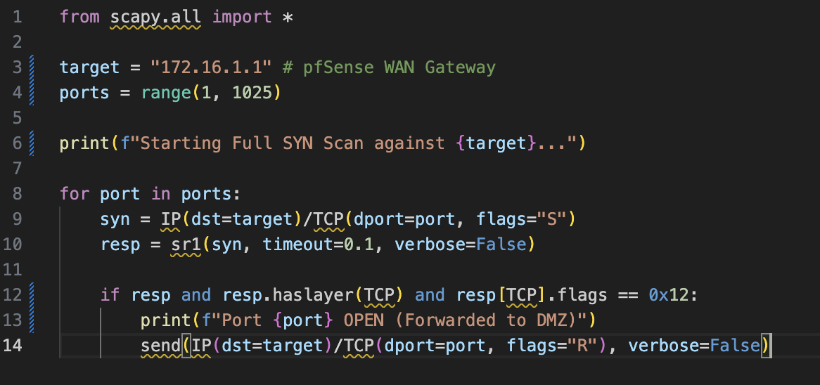
Script 2: Attack #2 – TCP SYN Scan

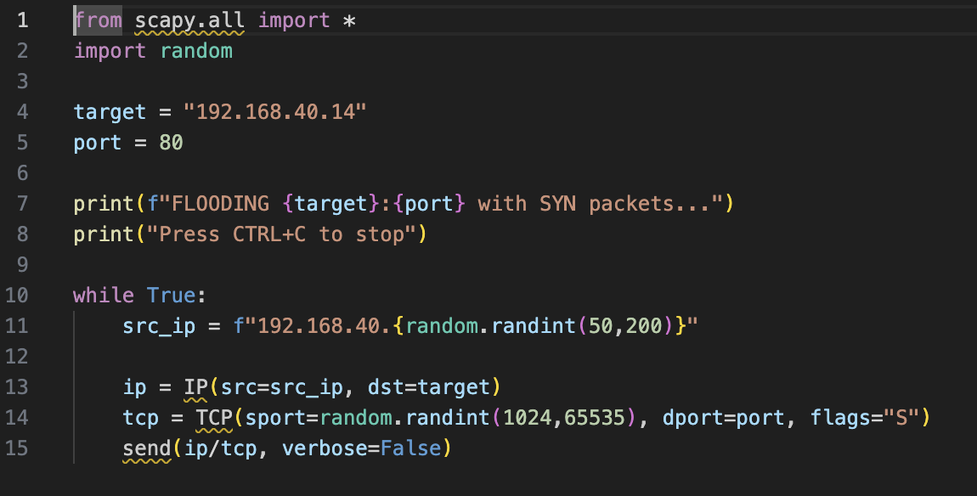
Script 3: Attack #3 – TCP SYN Flood

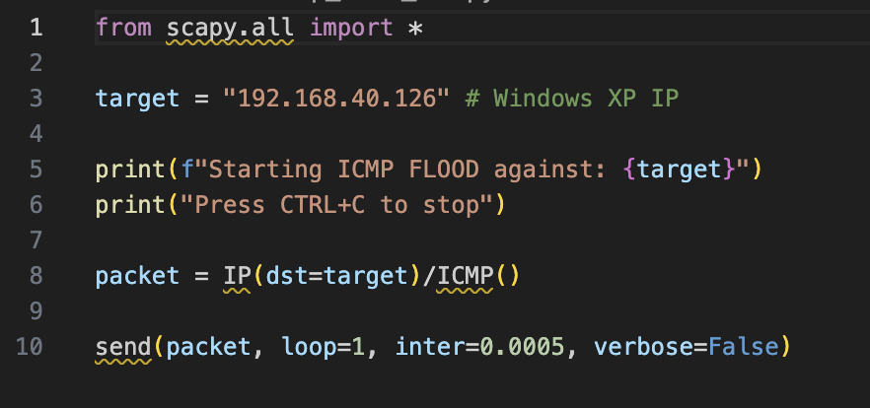

Script 4: Attack #4 – ICMP Flood

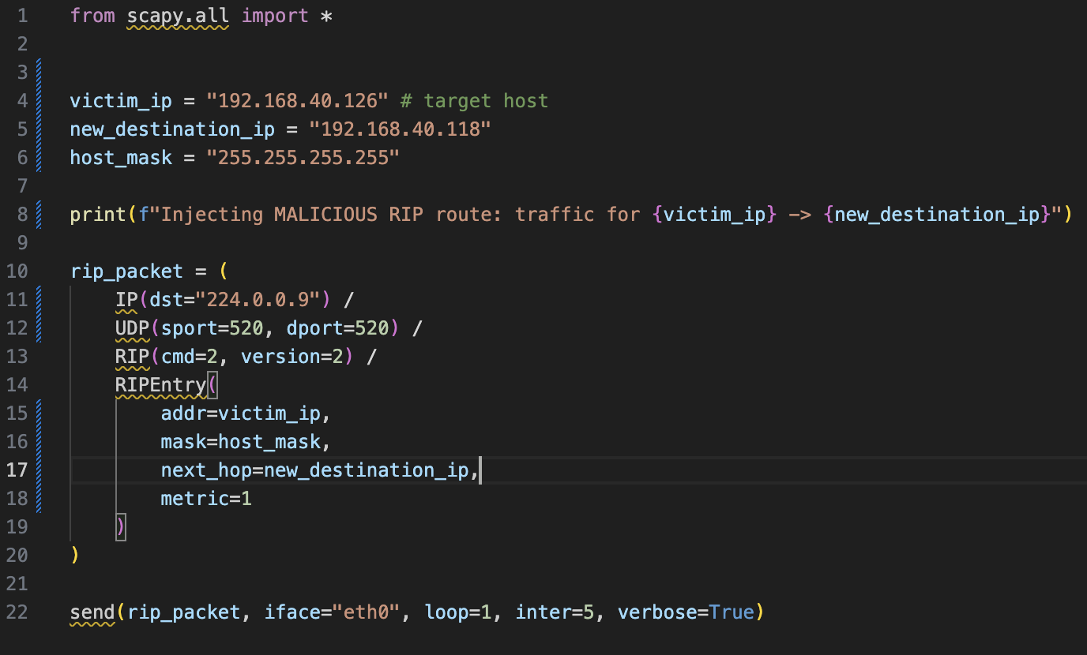
Script 5: Attack #5 – RIP Attack

Wireshark Excerpts
Wireshark capture 1: Attack #1 – ARP Sweep

Wireshark capture 2: Attack #2 – TCP SYN Scan

Wireshark capture 3: Attack #3 – TCP SYN Flood

Wireshark capture 4: Attack #4 – ICMP Flood

Splunk Captures
Splunk capture 1: Attack #2 – TCP SYN Scan

Splunk capture 2: Attack #3 – TCP SYN Flood
Splunk capture 3: Attack #5 – RIP Attack

List of figures
Figure 1: Clients zone firewall rules……………………………………………………..14
Figure 2: DMZ zone firewall rules…………………………...…………………………..14
Figure 3: Servers zone firewall rules……………………………..……………………..14
Figure 4: LAB zone firewall rules………………………………………………………..15

List of tables
Table 1: List of abbreviations……….……………………………………………………3
Table 2: Endpoint addressing table…………………..…………………………………8
Table 3: LAB subnet & Router Link table……………………………………………….8
Table 4: External network & VPM Allocation…………………………………………...9
Table 5: VLAN Setup…………………………………………………………………….10

